Insurance Fraud Detection Using Machine Learning

Dr. Santhi V

Department of Computer Science and Engineering

PSG College of Technology

Coimbatore

Dinesh Baabu R

Department of Computer Science and Engineering

PSG College of Technology

Coimbatore

Arul Arasu N

Department of Computer Science and Engineering

PSG College of Technology

Coimbatore

Lokajit G

Department of Computer Science and Engineering

PSG College of Technology

Coimbatore

Dhanaseelan V

Department of Computer Science and Engineering

PSG College of Technology

Coimbatore

Sudarshan S

Department of Computer Science and Engineering

PSG College of Technology

Coimbatore

**Abstract – The prevalence of fraudulent activities within the insurance industry necessitates the implementation of innovative and novel solutions. The primary objective of this particular project is to devise a model for the detection of fraudulent activities in the realm of health insurance. This model is designed to classify insurance claims with a remarkable degree of precision, efficacy, and dependability. In order to achieve this objective, a comprehensive dataset comprising insurance claims from patients who have been admitted to a medical facility is utilized. This dataset undergoes various data pre-processing procedures, such as standardization and coding techniques, to render it comprehensible to machines. Moreover, only those features that facilitate the process of learning are retained. During the process of conducting exploratory data analysis, it was ascertained that the dataset was not balanced, thereby necessitating the utilization of sampling techniques. These techniques encompass the employment of balanced class weights, random undersampling, and oversampling. Further, this approach involves analyzing complex historical feedback data using advanced machine learning algorithms such as logistic regression, decision trees, random forests, and XGBoost. These algorithms are adaptive and continually improve their ability to detect fraudulent patterns by learning from past examples. When comparing four different models combined with different sampling techniques, the eXtreme Gradient Boosting model with SMOTE oversampling is identified as the best in terms of performance metrics like minimum log loss, misclassification rate, false positive rate (FPR), and maximum area under the curve (AUC), F1 score, Balanced Accuracy Score (BACC), Matthew Correlation Coefficient (MCC). This model can also be used to combat widespread insurance fraud through early detection, ultimately benefiting both insurers and policyholders in an ever-evolving environment.**

***Keywords - Insurance frauds, machine learning, logistic regression, decision tree, random forest, xgboost, fraud detection.***

I Introduction

In a world where uncertainties are an inevitable part of life, insurance serves as a safety net, providing financial protection and peace of mind. However, the unfortunate reality is that some individuals exploit the trust placed in insurance systems through deceitful practices known as insurance frauds. These fraudulent activities not only jeopardize the financial stability of insurance companies but also lead to increased premiums for honest policyholders.

Machine learning may detect fraudulent datasets of patient’s insurance claims admitted in a Health care or Hospital that analyzes the behavior patterns and identifies data that need to predict its statistics occurring in the dataset. This could ensure a secure phase from unwanted data that purifies the data to validate on the health care or hospital and insurance policy as well.

This project work collects insurance claim records and performs necessary data processing techniques to make it fitting to the machine learning models. Different machine learning models are trained with the data and evaluated with various performing metrics to ensure to come up with the right model. The features’ contribution towards the learning is identified through model interpretability. The details of the project work would be discussed in the forthcoming chapters.

Machine learning stands as a fundamental tool in bolstering defenses against insurance fraud, providing a sophisticated system capable of adapting to ever-changing fraudulent strategies. By scrutinizing extensive datasets, these models rapidly identify unusual behavioral patterns, facilitating the detection of potentially deceitful claims in insurance systems. Drawing on a diverse range of attributes such as claim histories, medical records, and demographic data, machine learning algorithms not only flag suspicious actions but also assist in refining and optimizing the overall efficiency of insurance claim procedures.

Moreover, the utilization of machine learning in spotting insurance fraud extends beyond mere identification, functioning as a proactive deterrent against deceptive activities. Continuously learning from fresh data and emerging trends, these models evolve to anticipate potential fraudulent tendencies, ultimately empowering insurance providers to preemptively manage risks and safeguard their offerings. The incorporation of machine learning methodologies signifies a notable advancement in combating fraudulent behaviors within the insurance realm, leading the path toward a more secure, streamlined, and robust insurance environment.

II. Literature Survey

Anokye et al, in their paper provides a detailed explanation of a new approach to healthcare fraud detection and prevention using machine learning and blockchain technology [1]. The authors explain that healthcare fraud is a serious problem in many countries, causing significant economic losses to insurance companies and government agencies The proposed method uses decision tree classification algorithms to analyze healthcare information and they are used to identify potentially misleading information and to include fraudulent information. However, the authors also acknowledge that there are some challenges in applying this approach to real-world health care settings. For example, there may be concerns about data privacy and security, as well as resistance from healthcare providers and insurance companies accustomed to traditional ways of handling data The authors suggest that these challenges can be addressed through policy with care and collaboration between stakeholders.

Sathya et al, This paper discusses the problem of fraudulent claims in the insurance industry and the limitations of traditional fraud detection techniques [2]. The paper proposes a novel approach for detecting insurance fraud using a hybrid machine learning classifier called eRFSVM, which combines Random Forest and Support Vector Machine algorithms.. The paper evaluates the proposed approach using a confusion matrix and various classification metrics. The results show that the eRFSVM classifier outperforms traditional fraud detection techniques in terms of accuracy and efficiency. The proposed approach demonstrates exceptional performance in determining the veracity of customer claims, with an exceptional accuracy of 97.176%. Also the values of specificity and sensitivity are exceptionally high. The paper highlights the potential of machine learning techniques for fraud detection in the insurance industry and the importance of secure information sharing among insurance agencies. The proposed approach can help insurance companies to detect fraudulent activities effectively and reduce unwarranted expenses. The paper also discusses of the proposed approach for detecting insurance fraud include the requirement for a large amount of data to train the machine learning model effectively, reliance on the accuracy of the data provided by insurance agencies, potential difficulty in detecting new types of fraud, and the need for significant computational resources to process large amounts of data.

R. Roy and K. T. George introduced a paper on "Detecting insurance claims fraud using machine learning techniques," [4] that focuses on detecting auto/vehicle insurance fraud using machine learning techniques. The authors focus on creating a set of rules and anomalies for creating raw data, which is dependent on a set of attributes. They then compare the performance of decision trees, random forests, and Naïve Bayes in detecting insurance fraud using a confusion matrix. The methodology adopted involves dividing the data into training and testing sets, and comparing the accuracy, precision, and recall of each method. The authors found that decision trees and random forests outperformed Naïve Bayes in detecting insurance fraud. The evaluation of the methodology involved comparing the performance of each method using a confusion matrix, and calculating accuracy, precision, and recall.

Urunkar et al proposed a machine learning approach that can analyze large amounts of data and identify patterns indicative of fraud [5]. They use a combination of supervised and unsupervised learning algorithms, including decision trees, random forests, and clustering. The authors evaluate their approach using a dataset of insurance claims and compare their results to those of traditional fraud detection methods. They find that their machine learning approach outperforms traditional methods in terms of accuracy and efficiency. However, they also note that there are challenges to implementing these techniques in real-world insurance settings, such as data privacy concerns and the need for ongoing model maintenance.The authors imply that defining the perfect algorithmic methods or implementing feature engineering techniques for improved performance might not be feasible due to the unique traits of different datasets. Their suggestion involves utilizing models tailored to specific business contexts and user preferences. This approach allows loss management units to concentrate on identifying new instances of fraud and ensuring that the models continuously adapt to detect them.

Sun et al introduced a novel approach, named Patient Cluster Divergence-based Healthcare Insurance Fraudster Detection (PCDHIFD) [7], designed to address the issue of camouflage responses in healthcare insurance fraud detection. To conduct their experiments, they utilized a substantial healthcare dataset consisting of around 40 million admission records from 10,000 patients over a five-year period. The methodology consisted of three key steps: first, the construction of a patient graph based on the most similar information at the patient level; second, the application of a clustering-based graph algorithm to identify significant clusters; and finally, the calculation of patient cluster divergence to determine the probability of fraud for each patient. This approach provides a comprehensive and effective means of detecting potential fraudsters within the healthcare insurance system, taking into account patient histories, diagnoses, and medical practitioner data.

III System Design

Fig 1 shows the sequence of phases in building a model to classify the insurance claims with optimal performance. Initially the data is fetched from the data store as individual records in an uninterpretable way for the model [10]. The data must be pre-processed before being injected to the model. This phase includes data cleaning, feature engineering by deriving necessary attributes from existing ones and feature selection. The next phase is the building of models using different machine learning algorithms with the training data. The trained model is able to classify the unsupervised data as fraudulent or legit. The model shows the result of the legitimacy of the input to the user which is considered as the responding phase. The model’s decision is supported by its confidence score which should also be considered.

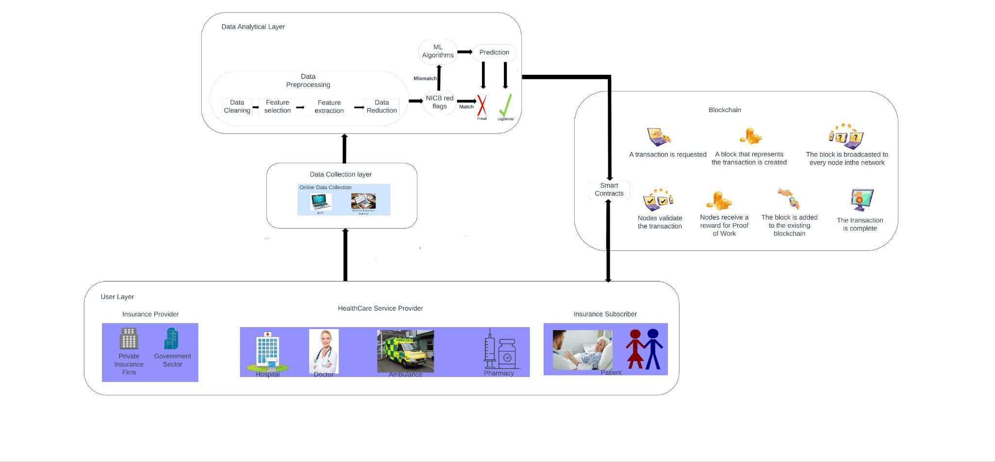

Fig 1 – System Architecture

1. *A. Dataset Introduction*

This project uses eight data files [8] out of which 4 are for training purposes and 4 are used in testing the model. There are 4 types of data where each type has one file for training and testing. The types of data file are discussed below:

* Inpatient Data offers valuable information on the insurance claims submitted for individuals who have been admitted to hospitals. It includes additional details such as admission and discharge dates, as well as the admit diagnosis code.
* Outpatient Data provides information on insurance claims for patients who visit hospitals but are not admitted. It captures relevant details associated with their hospital visits.
* Beneficiary Details Data encompasses KYC details of beneficiaries, including health conditions and the region they are affiliated with.
* Provider Data contains Provider ID. In the training file, the Provider ID is mapped with target value - Potential Fraud, whereas in the testing file only the Provider ID is given.

*B. Exploratory Data Analysis*

Checking out data, also called Exploratory Data Analysis (EDA), is like the detective work of data analysis. It's where you dig into your datasets at the start to figure out what's going on, find interesting stuff, and guess some ideas. Think of it as getting to know your data before you jump into more complicated math or computer stuff. EDA uses simple summaries, pictures, and graphs to uncover connections, trends, and things that seem a bit strange in the data. By doing this detective work, analysts can make smart choices about what to do next with their analysis, fix any data issues, and decide how to build their models.

1. *Provider Dataset*

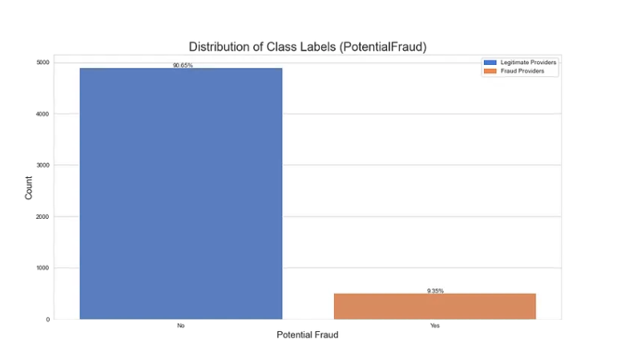

Fig 2 – Distribution of Class Labels

Fig 2 shows the distribution of class labels in the given dataset and it indicates that the dataset is hugely imbalanced when classified based on the training data [9]

1. *Beneficiary Dataset*

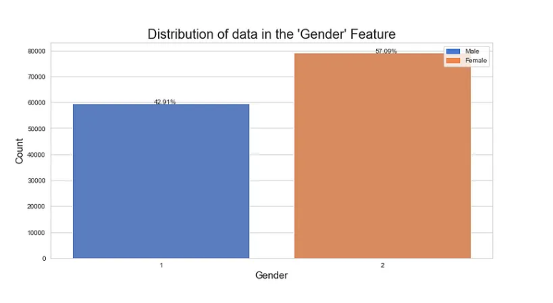

Fig 3 – Distribution of data in the ‘Gender’ Feature

Fig 3 shows the distribution of data in the ‘Gender’ Feature. It shows 57.09% of the beneficiaries are females and 42.92% are males. As opposed to the previous graph, this one is close to being perfectly balanced.

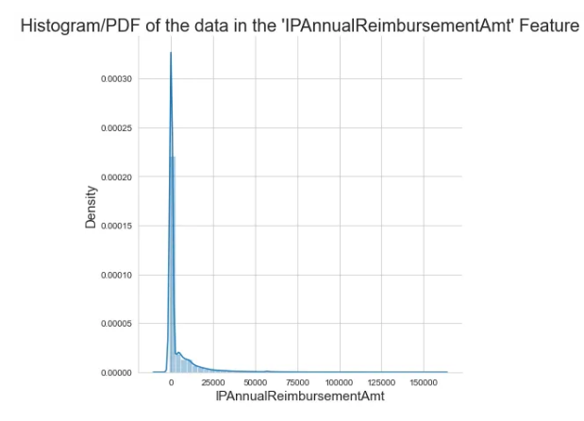

Fig 4 – Histogram of the data in the IP Annual reimbursement Amount

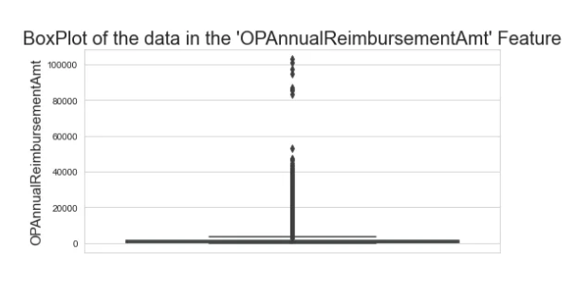

Fig 5 – Histogram of the data in the OP Annual reimbursement Amount

For Inpatient (Fig 4) and Outpatient (Fig 5) Annual Reimbursement Amount feature ranges mostly between 0 to 5000 and the Inpatient and Outpatient Annual Deductible Amount feature ranges between 0 to 2000. This means that the rest of the plotted points are outliers which shouldn’t be removed as they may be potential frauds.

1. *Data Preprocessing*
2. *Data Cleanup*

Renamed the 'County' column to 'Country' for consistency, Standardized binary columns ('Renal Disease Indicator' and 'Chronic Condition') to have values of 0 or 1, Replaced missing values in 'DeductibleAmtPaid' with 0, Dropped columns with all null values, Encoded 'PotentialFraud' labels as 1 for 'Yes' and 0 for 'No'.

1. *Data Processing*

Converted date-related columns to DateTime format, Calculated 'ClaimSettlementDelay' as the difference between 'ClaimEndDt' and 'ClaimStartDt', Calculated 'TreatmentDuration' as the difference between 'DischargeDt' and 'AdmissionDt' for inpatient records.

1. *Feature Engineering*

Created a new feature 'Age' based on beneficiaries' date of birth and date of death, Added 'IsDead' feature to indicate whether a beneficiary is deceased, Created new features 'TotalClaimAmount,' 'IPTotalAmount,' and 'OPTotalAmount' by aggregating relevant columns, Generated an 'IsInpatient' feature based on the presence of 'DiagnosisGroupCode' [11].

IV. Implementation

1. *Feature Selection*
2. *a. Chi-Squared Feature Selection*

Chi-squared feature selection is a statistical technique used in machine learning and data analysis to identify and select the most appropriate features from a dataset, especially when dealing with categorical or discrete data. It measures the statistical independence between each feature and a target variable, and constructs contingency tables to tabulate the relationships between feature categories and the target variable. Features with higher chi-squared scores are considered more informative and prioritized for inclusion in predictive models. Chi-squared feature selection is valuable for dimensionality reduction, model interpretability, and improving predictive accuracy in classification tasks.

*b. Mutual Information*

Mutual Information (MI) is a metric that evaluates the interconnection between data attributes, particularly

independent variables, and the target variable. It quantifies the value of an attribute in reducing uncertainty associated with the target variable. High MI scores indicate the value of attributes in providing insights into the target variable. While training with Logistic Regression an accuracy of 66.32 is obtained. Further, the Reduction in Entropy can be calculated as:

Reduction in Entropy = Total Entropy - Entropy of Target Variable

Total Entropy H(Y) is given by,

Where,

p0 -> proportion of samples in class 0

p1 -> proportion of samples in class 1

And the Entropy of target variable is calculated as follows,

Where,

P(X = x) -> probability of feature having value x

H( Y | X = x) -> conditional entropy of target variable given that the feature has value x.

*c. Spearman’s Correlation Coefficient*

Spearman's correlation coefficient (ρ) is a statistical tool used to measure the connection between variables. It involves assigning ranks to each variable's values individually and determining the disparities in these ranks for each pair of data points. This helps assess the strength and direction of the monotonic relationship between the two variables.

To calculate ρ, rank the values of each variable separately, calculate the differences between the ranks for each pair of data points, square each difference, and then calculate the Spearman's correlation coefficient. The range of ρ values ranges from -1 to 1, with -1 indicating a perfect negative relationship, 1 indicating a perfect positive relationship, and 0 indicating no particular relationship.

In real-world data, most ρ values fall between -1 and 1, with closer values indicating stronger correlation between variables. This tool is often used when data is ordinal or when a linear relationship is not appropriate.

We notice that some features exhibit strong Spearman Correlation Coefficients.

IPAnnualReimbursementAmt and IPAnnualDeductibleAmt (0.97) and OPAnnualReimbursementAmt and OPAnnualDeductibleAmt (0.66) are the highly correlated features and can be used to find the total claim amount.

When plotted against the class label, 'Gender', 'NoOfMonths_PartACov', 'ChronicCond_Depression', 'ChronicCond_Osteoporasis' and 'OPAnnualReimbursementAmt' are found to be very less correlated. But removal shouldn’t be done because a combination of these features might prove useful.

1. *Machine Learning Modeling*

This chapter details the model training using machine learning algorithms. The data after preprocessing and feature selection is fed to the model for learning. Since the machine learning models could interpret only numerical data, it is necessary to convert any categorical data to numerical. Encoding techniques are used to accomplish this task. In particular response encoding and one-hot encoding are adopted to transform the categorical features ‘State’, ‘Country’ to numerical. This finalized data is fed into four machine learning algorithms for performance comparison.

1. *Data Sampling*

An imbalanced dataset is a situation where a minority class has fewer examples than the majority class. To address this, techniques like balanced class weights, under-sampling, and over-sampling are used to ensure fairness and effective learning from all classes. Each of these techniques is applied sequentially after standardization and before fitting through the model using pipelines [18].

### *Balanced Class Weights*

In classification tasks with imbalanced class distributions, balanced class weights come into play. When we don't use these balanced weights, our model can end up favoring the majority class and performing poorly on the minority class. Balanced class weights solve this by assigning varying importance to the classes, giving extra weight to the minority group. This ensures that our model learns from both classes equally during training, promoting a fairer and more accurate outcome.

### *Under-Sampling*

In situations where we have a ton of data in the majority class and want a more balanced dataset, under-sampling is the way to go. This approach helps prevent the model from getting swamped by the majority class. It works by randomly taking out some examples from the majority group until we have about the same number of instances as in the minority class. This levels the playing field for our model and ensures it pays equal attention to both classes.

### *Over-Sampling*

Over-sampling is used when you have a limited amount of data for the minority class, and you want to balance the class distribution. It helps the model better learn the patterns in the minority class. It involves creating synthetic samples for the minority class using techniques like SMOTE (Synthetic Minority Over-sampling Technique) [17]. This increases the number of instances in the minority class.

*b. Decision Tree*

Decision tree modeling is a versatile machine learning technique suitable for both classifying and predicting data. Its main objective is to divide the dataset into subsets that are as similar as possible regarding the target variable [14]. This division process keeps repeating, forming a tree structure that guides predictions, moving from the starting point (the root node) down to a specific endpoint (a leaf node). The nitty-gritty of how this works will be discussed in the upcoming sections. What's interesting is that decision tree algorithms excel at figuring out which features are crucial for classification, making feature selection an inherent part of their operation. This feature-selection process can be fine-tuned using different approaches, such as the SSV criterion. [9].

Evaluation of Decision Tree Classifier is performed using,

1. Best Hyperparameters on Response Encoded Data without Sampling
2. Best hyperparameters on Response Encoded Data with balanced Class Weights
3. Best hyperparameters on Response Encoded Data with Random Undersampling
4. Hyperparameter tuning on Response Encoded Data with SMOTE Oversampling

## *c. Logistic Regression*

Logistic regression is a statistical model used for binary classification, where it predicts one of two possible outcomes based on input features. It calculates the probability of the target variable belonging to a particular class by using a logistic (sigmoid) function to transform the linear combination of features [13]. It's trained with labeled data and learns feature coefficients to best fit the observed outcomes. One of its strengths is interpretability, as it allows us to understand the influence of individual features on the prediction. Logistic regression finds applications in various domains, including medicine, finance, and marketing, making it a valuable tool for decision-making in situations involving binary classification problems.

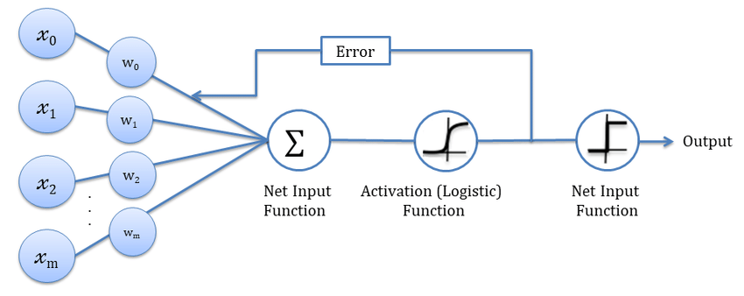

## *d. Random Forest*

A Random Forest is a machine learning ensemble method that handles classification and regression tasks. It consists of multiple decision trees working together to build a strong model [15]. The core concept is to address overfitting issues in individual decision trees and enhance the model's ability to make generalizable predictions. Data sampling is done through "bootstrapping," reducing the risk of overfitting. Feature selection is done by randomly selecting a subset of features to split in the decision trees. Each decision tree is constructed using a variant of the decision tree algorithm, such as CART. In classification tasks, the results are combined through a majority vote, while in regression tasks, predictions from different trees are averaged.

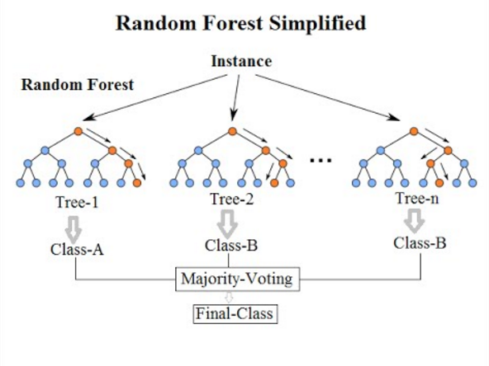

Fig 6 – Pictorial Representation of Random Forest

## *e. Xgboost*

XGBoost, an abbreviation for Extreme Gradient Boosting, represents a robust and widely favored machine learning technique recognized for its remarkable capabilities across diverse data-centric assignments [12]. Categorized within gradient boosting algorithms, it stands out for its proficiency and success in managing structured data sets. XGBoost combines multiple decision trees to create an ensemble model, which enhances predictive accuracy and reduces overfitting. It employs a gradient descent optimization technique to iteratively improve the model's predictions. XGBoost is highly versatile, capable of handling regression, classification, and ranking problems. Its robustness, speed, and feature selection capabilities make it a favored choice among data scientists and machine learning practitioners for achieving state-of-the-art results in predictive modeling and competitive data science competitions.

1. *Training the Model with best hyperparameters on Response Encoded Data with SMOTE Oversampling*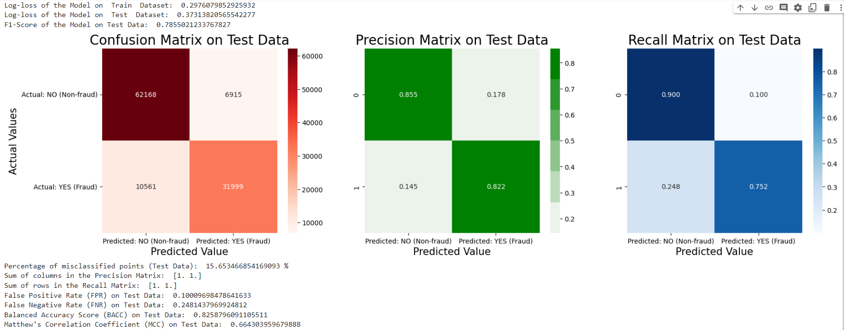

Fig 7 – Performance Metrics - XGBoost with SMOTE Oversampling

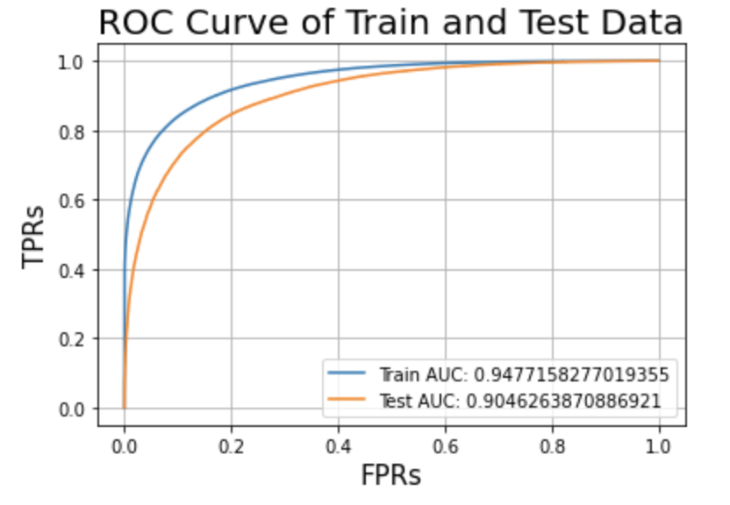

Fig 8 – ROC Curve - XGBoost with SMOTE Oversampling

## 

## 

## 

## *C. Best Model Selection*

| Model | Train Data | |
| --- | --- | --- |
| AUC | Log-loss |
| LR | 0.74094 | 0.57481 |
| LR - BCW | 0.74139 | 0.59742 |
| LR - RU | 0.74152 | 0.5988 |
| LR - SMOTE | 0.79221 | 0.54082 |
| DT | 0.86694 | 0.43362 |
| DT - BCW | 0.8656 | 0.45284 |
| DT - RU | 0.86093 | 0.45972 |
| DT - SMOTE | 0.89373 | 0.40121 |
| RF | 0.89265 | 0.40513 |
| RF - BCW | 0.97359 | 0.27579 |
| RF - RU | 0.97355 | 0.28446 |
| RF - SMOTE | 0.94208 | 0.32997 |
| XGB | 0.92598 | 0.36781 |
| RF - RU | 0.92511 | 0.36703 |
| RF - SMOTE | 0.94222 | 0.35101 |

| Model | TEST DATA | | | |
| --- | --- | --- | --- | --- |
| Log-loss | AUC | F1 score | % misclassification |
| LR | 0.57316 | 0.74464 | 0.54777 | 29.59 |
| LR - BCW | 0.5965 | 0.74497 | 0.62397 | 31.29 |
| LR - RU | 0.59831 | 0.74483 | 0.62432 | 31.49 |
| LR - SMOTE | 0.60103 | 0.71757 | 0.57263 | 31.49 |
| DT | 0.62828 | 0.83325 | 0.68552 | 22.56 |
| DT - BCW | 0.63311 | 0.83151 | 0.70404 | 24.1 |
| DT - RU | 0.64241 | 0.85882 | 0.69991 | 24.61 |
| DT - SMOTE | 0.49893 | 0.85931 | 0.70691 | 21.83 |
| RF | 0.47671 | 0.85847 | 0.69996 | 21.74 |
| RF - BCW | 0.48681 | 0.83704 | 0.70570 | 22.93 |
| RF - RU | 0.49762 | 0.82412 | 0.72196 | 23.72 |
| RF - SMOTE | 0.38447 | 0.90323 | 0.76912 | 17.42 |
| XGB | 0.46366 | 0.84323 | 0.69563 | 22.74 |
| XGB- RU | 0.46962 | 0.84257 | 0.71539 | 22.9 |
| RF - SMOTE | 0.39356 | 0.90463 | 0.76733 | 16.81 |

| Model | TEST DATA | | | |
| --- | --- | --- | --- | --- |
| FPR | FNR | BACC | MCC |
| LR | 0.15316 | 0.52982 | 0.65951 | 0.32963 |
| LR - BCW | 0.30928 | 0.31988 | 0.65981 | 0.36923 |
| LR - RU | 0.31590 | 0.31532 | 0.68533 | 0.36381 |
| LR - SMOTE | 0.23993 | 0.44527 | 0.65785 | 0.32107 |
| DT | 0.14606 | 0.35484 | 0.74595 | 0.51308 |
| DT - BCW | 0.23682 | 0.24741 | 0.75604 | 0.50407 |
| DT - RU | 0.22995 | 0.26201 | 0.75401 | 0.49935 |
| DT - SMOTE | 0.16501 | 0.30479 | 0.76734 | 0.53118 |
| RF | 0.13582 | 0.34274 | 0.76072 | 0.53673 |
| RF - BCW | 0.18353 | 0.28954 | 0.76346 | 0.52609 |
| RF - RU | 0.22632 | 0.25297 | 0.76535 | 0.52084 |
| RF - SMOTE | 0.12422 | 0.26005 | 0.80785 | 0.62339 |
| XGB | 0.13828 | 0.34523 | 0.75798 | 0.53072 |
| XGB- RU | 0.21905 | 0.24508 | 0.76793 | 0.52764 |
| XGB- SMOTE | 0.10379 | 0.27263 | 0.81179 | 0.63867 |

The table uses the following abbreviations - Logistic Regression (LR), Decision Tree (DT), Random Forest (RF), XGBoost (XGB) - the machine learning models paired with - Balanced Class Weights (BCW), Random Undersampling (RU), Synthetic Minority Oversampling Technique (SMOTE) - which is assessed through performance metrics like - Area Under the Curve (AUC), False Positive Rate (FPR), False Negative Rate (FNR), Balanced Accuracy (BACC) and Mathews correlation coefficient (MCC).

On observing the scores of various models (Fig 7.6), it is inferred that the Decision Tree model, Random Forest model, and XGBoost model all showed low false negative rates and high scores on evaluation metrics. The XGBoost model with Synthetic Minority Oversampling Technique achieved the best scores for most criteria, making it the final model.

*D.* *Model Interpretability*

Explainable AI (XAI) is a concept which includes a set of processes used to perceive insights from the decisions generated by AI and machine learning models in a human-understandable form.

LIME (Local Interpretable Model-agnostic Explanations) is one such concept which is used to understand how confident the final XGBoost model classifies an input [16]. It focuses on a local group of data points and it is applicable to any machine learning model as it treats the model as black box. LIME takes a datapoint and produces samples around the datapoint. It then uses RBF to generate weights for the points generated. The points closer to the original data are assigned a greater weight compared to the points distant.

1. *Datapoint with Positive Prediction*

LIME takes the first data point and predicts it as positive based on its Linear Ridge Regression with a confidence of 89% (Fig 8.1). The values of ‘IsSamePhysMultiRole1’ and ‘PhysRoleCount’ increases the claims chances to be classified as fraudulent. Other values such as ‘PHY412132’, ‘TreatmentDuration’, ‘ClmProcCode_9904’, ‘PHY337425’, ‘ClmProcCode_8154’, ‘TotalClaimAmount’, ‘ClmProcedureCode_2’, ‘PHY330576’ decrease the chance a bit for the claim to be classified as fraudulent.

1. *Datapoint with Negative Prediction*

LIME takes the zeroth data point and predicts it as negative based on its Linear Ridge Regression with a confidence of 79% (Fig 8.2). The values of ‘IsSamePhysMultiRole1’ and ‘PhysRoleCount’ increases the claims chances to be classified as non-fraudulent. Other values such as ‘PHY412132’, ‘TreatmentDuration’, ‘ClmProcCode_9904’, ‘PHY337425’, ‘ClmProcCode_8154’, ‘TotalClaimAmount’, ‘ClmProcedureCode_2’, ‘PHY330576’ decrease the chance a bit for the claim to be classified as non-fraudulent.

V. Conclusion

In conclusion, this project successfully adopts a machine learning model for the detection of fake insurance claims, a critical issue in the insurance industry. By analyzing the previous solutions for this problem it is inferred that wide feature engineering and optimal feature selection can improve the model’s performance. The system model is developed and detailed with a sequence of sub-phases in each phase. Exploratory Data Analysis helped to identify the non-contributing features and exposed the imbalanced nature in the dataset.

Data preprocessing techniques like data cleaning and standardization tuned the dataset towards learning. Three different feature selection techniques namely Spearman correlation, Mutual information and Chi-squared feature selection were attempted and spearman correlation was found to elucidate the relationship between the features and target variable. The imbalance in the dataset is moderated using balanced class weights, undersampling and oversampling. The data was trained with machine learning models like decision trees, random forests, logistic regression, and XGBoost. Different encoding techniques like response encoding and one-hot encoding were helped to ease the model’s training process.The models were assessed based on real-world performance metrics like accuracy, precision, recall, and F1-score. The results provided valuable insights, helping in the understanding of when each method shines and where it might fall short.

However, it became evident that the XGBoost algorithm with response encoding, when combined with the Spearman correlation and oversampling using SMOTE, outperformed the competition in terms of overall accuracy with the following values for the chosen performance metrics : Log loss - 0.39356 , Misclassification percentage - 16.81%, FPR - 0.10379, AUC - 0.90463, F1 score - 0.76733, BACC - 0.81179, MCC - 0.63867.

This model will greatly benefit the insurance industry, enhancing its ability to combat fraudulent activities and protect the interests of both insurers and policyholders. Furthermore, this research underscores the importance of selecting the right combination of machine learning algorithms and feature selection techniques to achieve optimal results in complex, real-world problem-solving scenarios.

References

1. “A novel fraud detection and prevention method for healthcare claim processing using machine learning and blockchain technology Anokye Acheampong Amponsah ∗ , Adebayo Felix Adekoya, Benjamin Asubam Weyori “
2. Sathya, M. ., & Balakumar , B. . (2022). Insurance Fraud Detection Using Novel Machine Learning Technique. International Journal of Intelligent Syms and Applications in Engineering, 10(3), 374–381. Retrieved from <https://ijisae.org/index.php/IJISAE/article/view/2178>
3. “Naga Ramya Bhamidipati*, Varsha Vakkavanthula*, George Stafford*, Masrik Dahir*, Roshan Neupane*, Ernest Bonnah, Songjie Wang, J. V. R. Murthy, Khaza Anuarul Hoque, Prasad Calyam University of Missouri-Columbia, USA; Jawaharlal Nehru Technological University, India. “
4. R. Roy and K. T. George, "Detecting insurance claims fraud using machine learning techniques," 2017 International Conference on Circuit, Power and Computing Technologies (ICCPCT), Kollam, India, 2017, pp. 1-6, doi: 10.1109/ICCPCT.2017.8074258.
5. Urunkar, Abhijeet & Khot, Amruta & Bhat, Rashmi & Mudegol, Nandini. (2022). Fraud Detection and Analysis for Insurance Claims using Machine Learning. 406-411. 10.1109/SPICES52834.2022.9774071.
6. Inayatulloh, Siti Elda Hiererra, Prasetya Cahaya S, Rozil Toyob, Nico Djundharto Djajasinga , Sawqi Saad El Hasan, Rofiq Noorman Haryadi, Rivaldhy N. Muhammad,“ Blockchain technology of fraud Detection and Risk Prevention in Insurance Industry “. Proceedings of the 3rd South American International Industrial Engineering and Operations Management Conference, Asuncion, Paraguay, July 19-21, 2022. 47.docx (googleusercontent.com) [6]
7. Sun C., Li Q., Li H., Shi Y., Zhang S., Guo W., “Patient Cluster Divergence Based Healthcare Insurance Fraudster Detection”, IEEE Access, Vol. 7, pp. 14162–14170, 2019. <https://ieeexplore.ieee.org/document/8576507>
8. <https://www.kaggle.com/datasets/rohitrox/healthcare-provider-fraud-detection-analysis>
9. <https://www.kaggle.com/datasets/arashnic/imbalanced-data-practice>
10. [https://labelyourdata.com/articles/data-collection-methods-AI#:~:text=Simply%20 put%2C%20data%20collection%20 is,fed%20into%20an%20 ML%20mod](https://labelyourdata.com/articles/data-collection-methods-AI#:~:text=Simply%20)
11. K. Grabczewski and N. Jankowski, "Feature selection with decision tree criterion," Fifth International Conference on Hybrid Intelligent Systems (HIS'05), Rio de Janeiro, Brazil, 2005, pp. 6 pp.-, doi: 10.1109/ICHIS.2005.43.
12. <https://xgboost.readthedocs.io/en/stable/python/python_intro.html>
13. <https://scikit-learn.org/stable/modules/generated/sklearn.linear_model.LogisticRegression.html>
14. <https://scikit-learn.org/stable/modules/generated/sklearn.tree.DecisionTreeClassifier.html>
15. <https://scikit-learn.org/stable/modules/generated/sklearn.ensemble.RandomForestClassifier.html>
16. <https://towardsdatascience.com/lime-explain-machine-learning-predictions-af8f18189bfe>
17. <https://machinelearningmastery.com/smote-oversampling-for-imbalanced-classification/>
18. <https://scikit-learn.org/0.16/modules/generated/sklearn.pipeline.Pipeline.html#:~:text=The%20purpose%20of%20the%20pipeline,as%20in%20the%20example%20below.>